Time Entry and Submittal – Positive Duration Quick Reference Guide
Last Updated:11/13/2023
Employees assigned the Positive Duration time entry profile are required to enter the number of hours worked on each workday. Timesheets must be submitted after you have worked your final day or shift before the end of each week. After submitting your timesheet, it flows to your supervisor for approval.
Contents
Responsibilities 1
Employee Responsibilities 1
Supervisor Responsibilities 1
Overtime 1
Timekeeping in SuccessFactors 2
Accessing SuccessFactors 2
Multiple Positions – Selecting the Correct Timesheet 2
Entering Working Time 2
Saving and Submitting 4
Amending a Timesheet After Submitting 4

Responsibilities

Employee Responsibilities
- Accurately recording time worked
- Selecting the appropriate job when recording time (if the employee records time for multiple jobs)
- Proactively working with their supervisor to resolve issues as needed
- Ensuring that their time is recorded completely and accurately and submitted for supervisor approval following their final work day of each week.
- Remember: The time entered into the system will be considered true and accurate as of the end of an employee’s pay period. It is the employee’s responsibility to review their time often (at least at the end of each shift and at the end of the pay period) to make sure the recorded hours are true and correct and to review and confirm the accuracy of any changes that a supervisor makes to time entries.

Supervisor Responsibilities
- Proactively working with their employees to resolve issues as needed
- Reviewing/approving all time sheets for all of their employees by 10:00 am on the Monday following the end of each pay period
- Proactively working with the business office to update employee work schedules and report costing exceptions for their employees’ time worked
- Remember: The time entered into the system will be considered true and accurate as of the end of an employee’s pay period. It is the employee’s responsibility to review their time often (at least at the end of each shift and at the end of the pay period) to make sure the recorded hours are true and correct and to review and confirm the accuracy of any changes that a supervisor makes to time entries.

Overtime
SuccessFactors adheres to the University policy regarding overtime. When a full-time employee records over 40 hours in a workweek, the time will be designated as overtime. “Hours worked” in a work week will consist only of hours actually worked. (Exception: Worker’s Compensation, University Holidays).

Overtime for employees with multiple positions will be charged to each position based on the ratio of hours worked across the employee’s positions for that week.

Timekeeping in SuccessFactors

Accessing SuccessFactors
Access the Employee Launchpad SuccessFactors.  Log in with your username and password. |  | https://one.purdue.edu/

Multiple Positions – Selecting the Correct Timesheet
If you hold multiple positions, use the Change Selected Employment menu to select the position for which you would like to record time | 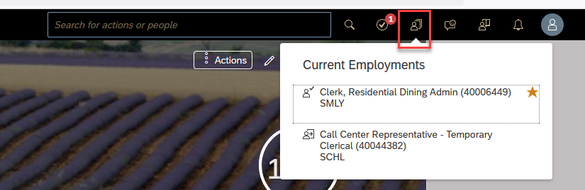
If the multiple positions are similarly named, click My Profile to validate that the correct position has been selected  Review Employment Details to validate you are recording on the correct timesheet | 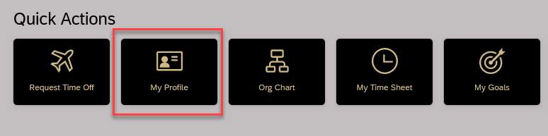  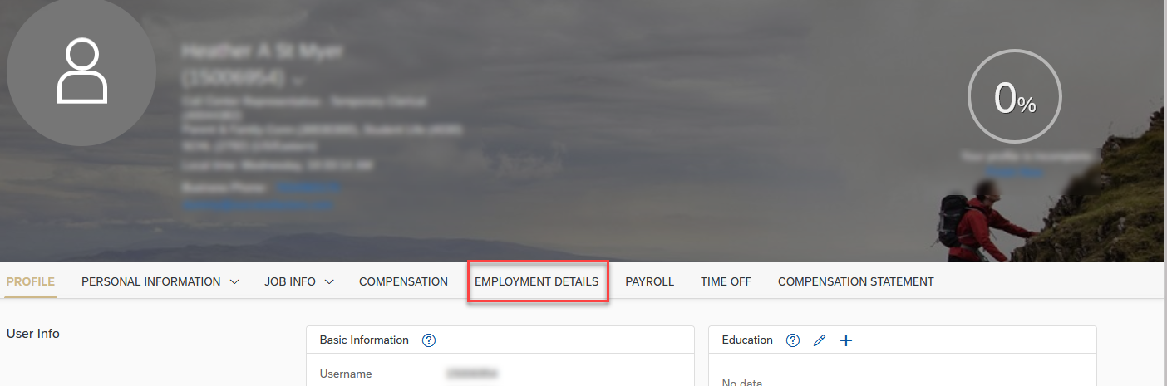

Entering Working Time
Select My Time Sheet under Quick Actions | 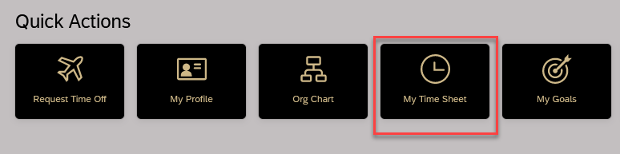
- Use arrows to navigate to correct the week/day  - Click to select the day you want to record time  - Click Record  - Select Time Type (most likely Working Time)  - Type total hours worked as Duration  - Add Cost Override information, when applicable  - Click Save  - Once recorded the Recording icon appears  - Click Submit after all hours for the week are recorded | 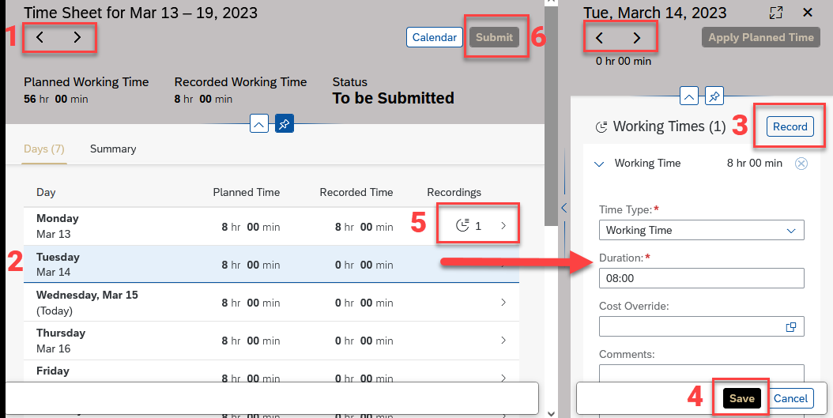  When entering time, enter the hours and minutes worked, i.e., 1 hour and 42 minutes worked = typing 0142 which will populate the Duration field to 01:42.  If only need hours (and not minutes), simply type the hours worked, i.e., 8, and then click Save. It will populate the Duration filed to 08:00.
The Summary reflects Time Valuation Results
- Regular includes the total hours worked
- Note: Overtime will only appear once the total time worked entered for the week exceeds the overtime threshold (typically, 40 hours).
- The Total does not reflect non-worked time such as leaves and holidays.
Enter cost overrides while recording time, when applicable. Click the search icon in the Cost Override field and start typing name of the account, then select the appropriate account and click Ok. Double-check duration or hours are correct. Click Save when done.

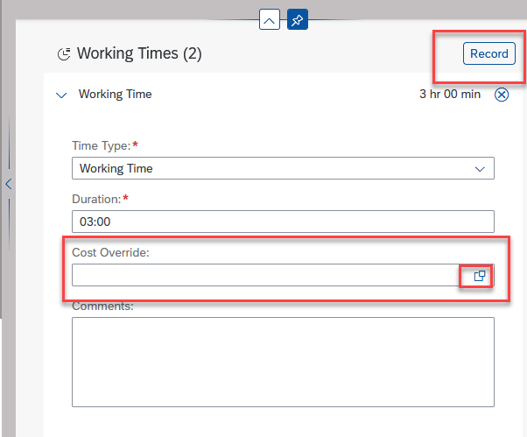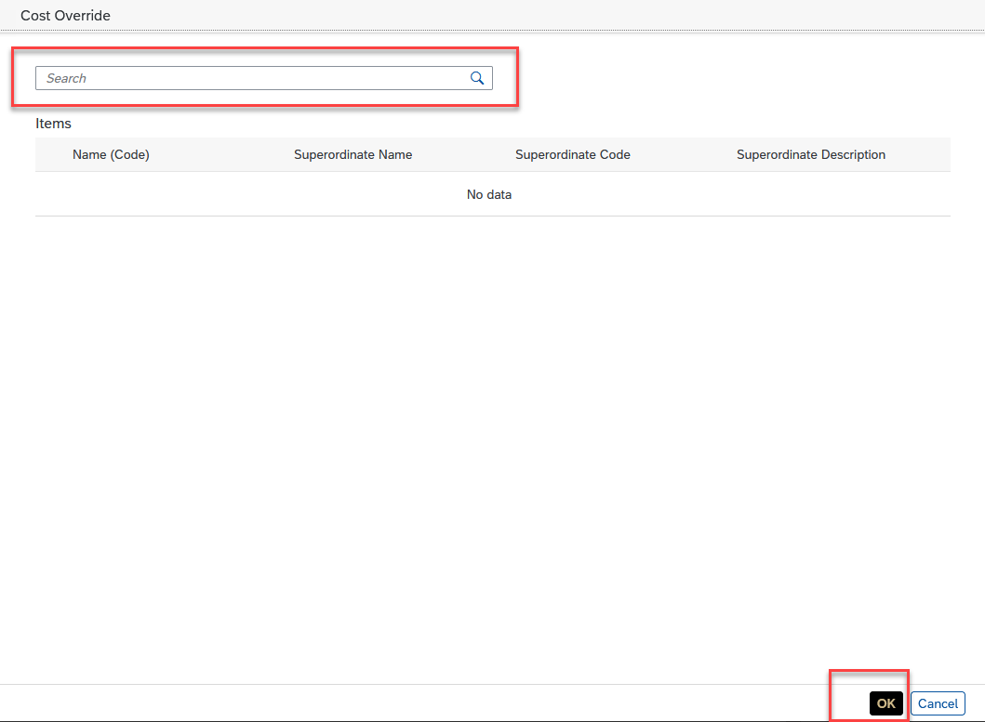

Saving and Submitting
Time Sheets in SuccessFactors are weekly; pay is distributed bi-weekly.
Click Submit after the Time Sheet is complete. This moves it to the supervisor. | 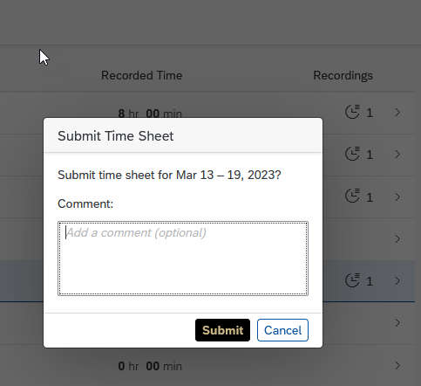

Amending a Timesheet After Submitting
Employees are able to edit time sheets (even if already approved) that are within the current or two previous pay periods. To edit time sheets further in the past, contact your supervisor. After a timesheet is edited, it flows to the supervisor for approval.
Click Withdraw to edit a Time Sheet sent for approval.

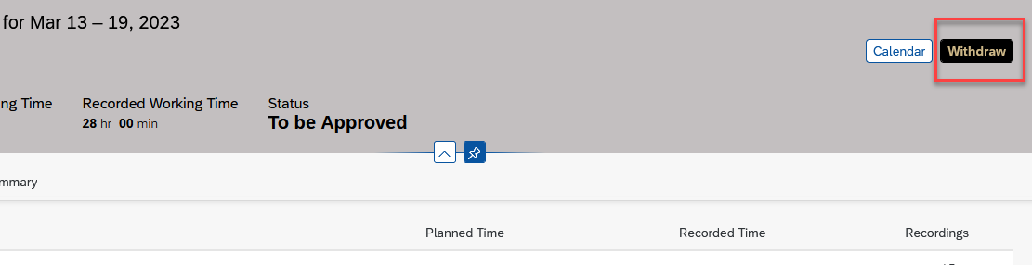

It will remind you to Submit (again) after entering or correcting your time recording.
